GRADUATE SCHOOL
2015 APPLICATION GUIDE

Department of
Chemical and Biological
Engineering

CONTENTS
02. Message from the President
03. Introductions to Department
08. Admission Guide
09. Campus Map

Message from the President
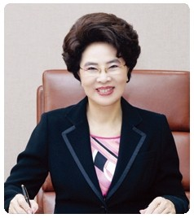
“Academic excellence and international research will make Gachon University globally competitive”
Gachon University is set to become one of the “Top 10 Private Universities” in just a few years, accomplishing a world renowned reputation as a center for academic excellence and a source distinguished intellect.

A university is a home, a place where a student's intellect is nurtured with knowledge and wisdom. While a university's success depends on the quality and future achievements of its students, such success is not guaranteed.
The university must create the best possible environment for education, where the potential of the students can blossom.
Gachon University, located in Seongnam city - 5 minutes from Seoul - was created as a result of a merger of two 4-year universities, which is the first case of such a merger in Korea. It suggested the vision for the future in order to define the future outlook of the school, and consolidated the strength of all members of the University and thus maximizes the synergy effects of the merger.
When I was put in charge of managing the University, I pledged that "Gachon University would become one of the 'Top 10 Private Universities' in the country within few years." Not only do I stand by this promise, I will take it further, and make sure that the university becomes one of the world's most prestigious institutions.
I hope that all will identify with Gachon University's vision for growth and success in the 21st century.


Chemical and Biological Engineering (CBE) occupies a unique position at the interface between molecular sciences and engineering, intimately linked with the fundamental subjects of chemistry, biology, mathematics and physics, and in close collaboration with fellow engineering disciplines like materials science, computer science, mechanical and electrical engineering. Chemical engineering offers unparalleled opportunities to do great things.
Gachon University’s CBE department offers programs of research and teaching which span the breadth of chemical and biological engineering with unprecedented depth in fundamentals and applications. Graduate study at CBE offers the opportunity to do important, leading-edge research in any of a broad range of innovative areas. Our graduate program covers the application of chemical and biological engineering to a variety of specific areas, including energy and the environment, nanotechnology, polymers and colloids, surface science, catalysis, biotechnology and biomedical processes, with a track focusing on chemical and biological engineering for students interested in the emerging biotech and life science industries.
Professors of CBE are managing Nano Particle Technology Innovation Center, Advanced Materials & Applied Technology Research Center, and Bionano Sensor Research Center, which are financially supported by Gyeonggi-do and Ministry of Knowledge Economy of Korean government. Great Numbers of undergraduate and graduate students participate in these affiliated research centers and researchers and graduate school is activated with best leveled research activities.

CBE Research Activities
CBE Building

Academic Program
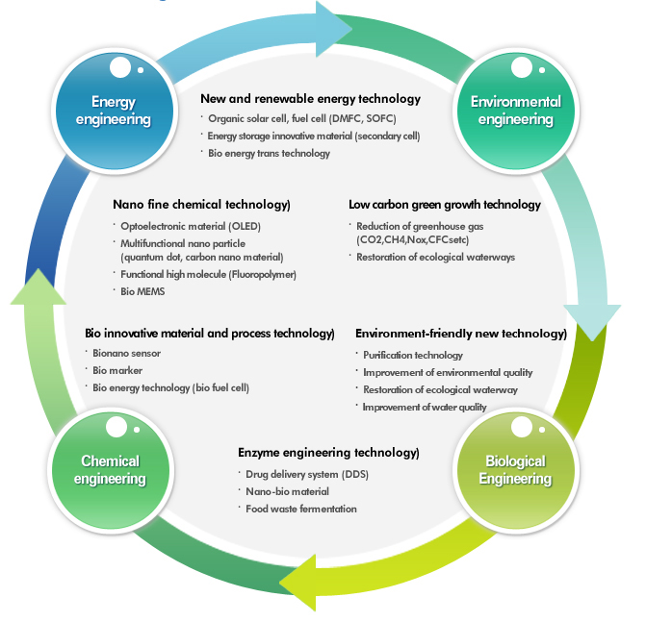
Carrier
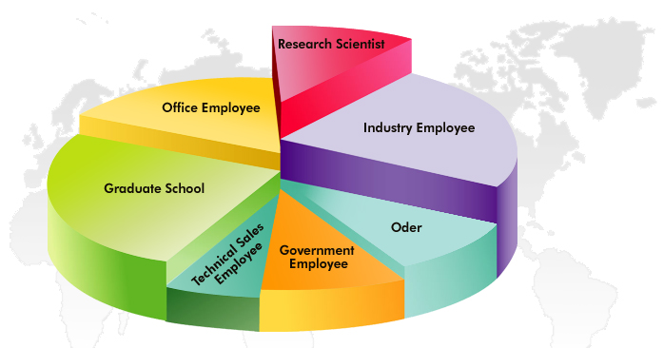
Faculty / Research Area

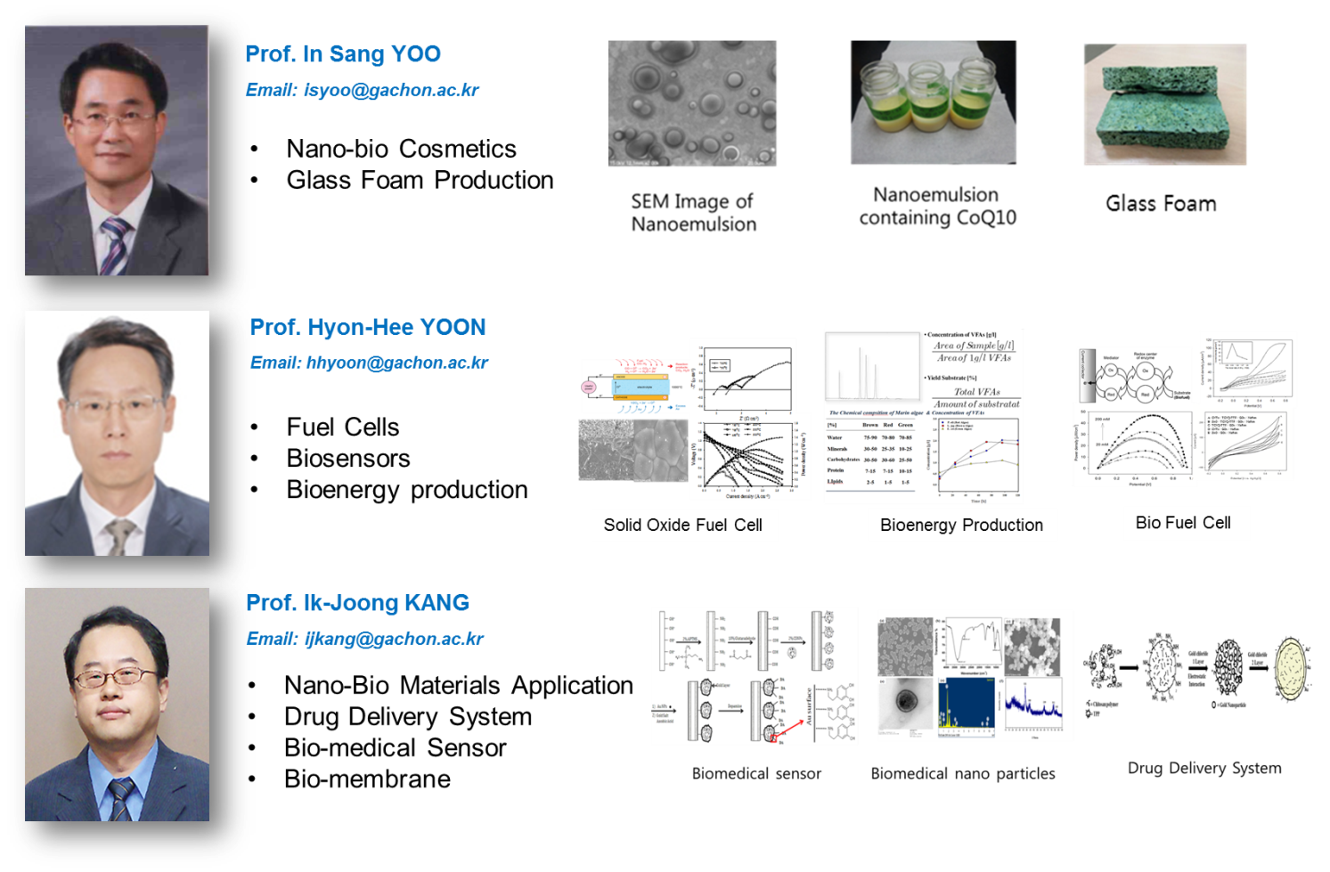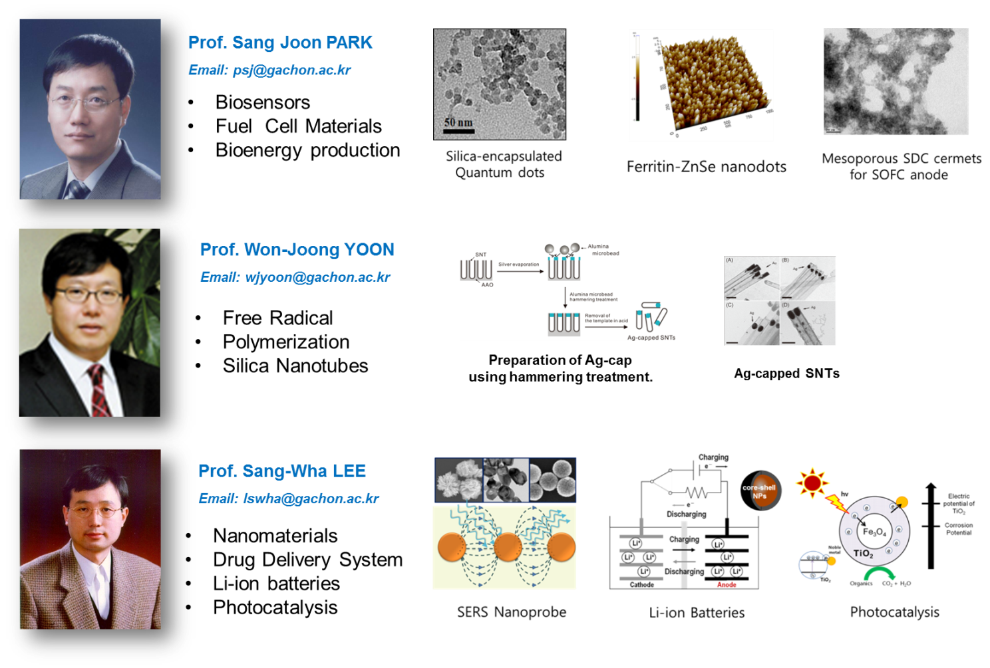
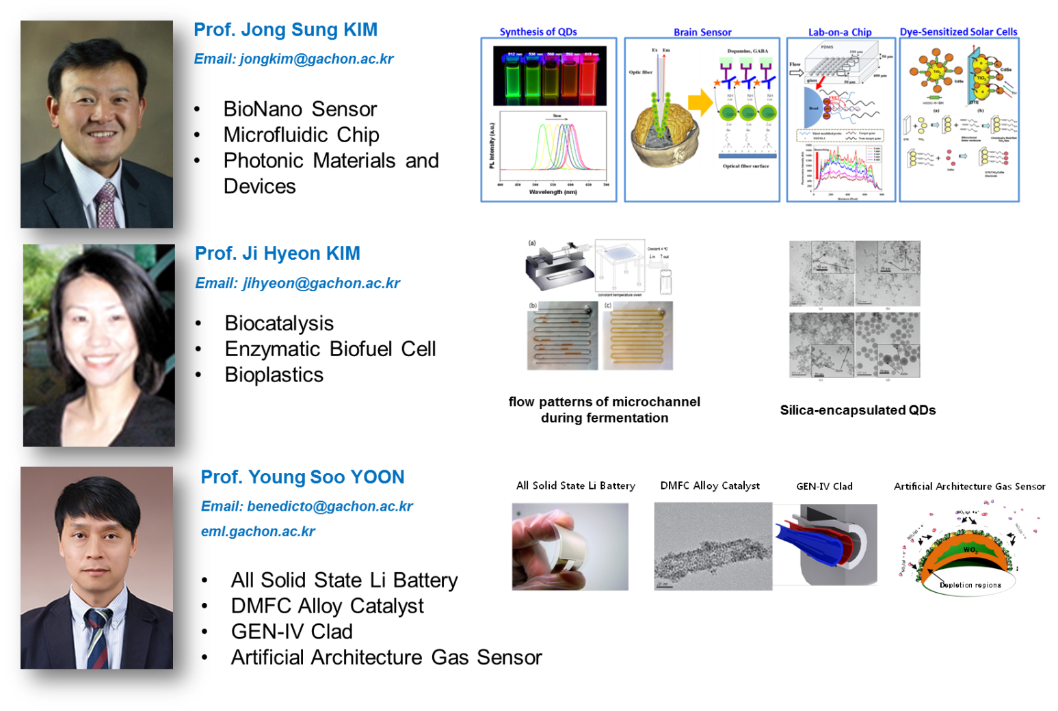
Affiliated Research Centers
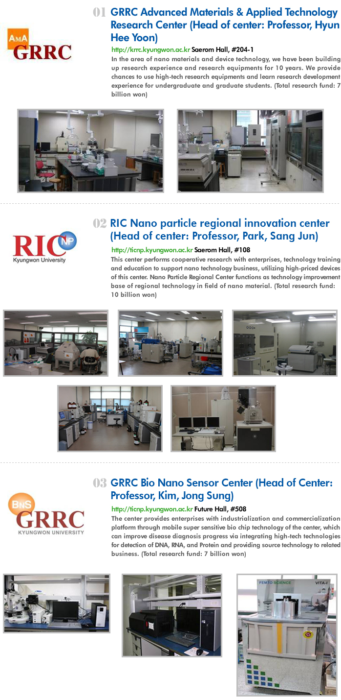
Admission Guide

Application Process
Degree Awarded: MS, PhD, MS/PhD (MS+PhD combined degree is recommended)
Course Fees: Gachon University provides tuition scholarships (12,000,000 won/year) to every graduate student of CBE
Maintenance Stipend: In addition the college provides a monthly stipend of 600,000 won (for MS students) and 800,000 won (for PhD students) to help with you living costs.
Accommodation: Please contact the accommodation office at the university or drop them an email at http://www.dasomkwan.net/
Application Dates: MS courses 12th May - 30th May, 2014. PhD and Post-doctoral candidates contact individual professors for openings.

Required Documents (Graduate Applicants)
- Please provide a copy of your undergraduate transcripts (summation of yearly subject grades, scores)
- English proficiency interview. Students, who cannot attend the interview, please send us a copy of IETLS or TOEIC score. English Language requirements vary by courses and college but are usually the equivalent of IELTS 6.0-7.5
- One sealed letters of recommendation must be sent directly to the graduate admissions officer by your undergraduate professor.
- Self-introduction assay describing yourself and your research interests (300 word minimum)
- Application forms and additional information can be downloaded from the following link. http://www.gachon.ac.kr/english/sub02/02_dept01.jsp
- Contact Information: For more information, please contact Prof. Jongsung Kim, Department head of CBE graduate program. Email: jongkim@gachon.ac.kr
- Prof. Jongsung Kim will visit Sandong University on 13-15 April. He will have an interview with students who want to apply for graduate program of CBE. (Date, time will be announced)

Campus Map
Directions


GGachon University
San 65, Bokjeong-dong, Sujeong-gu, Sungnam, Gyeonggi-do 461-701, Republic of Korea
+82-31-750-5364 / chemeng@gachon.ac.kr

